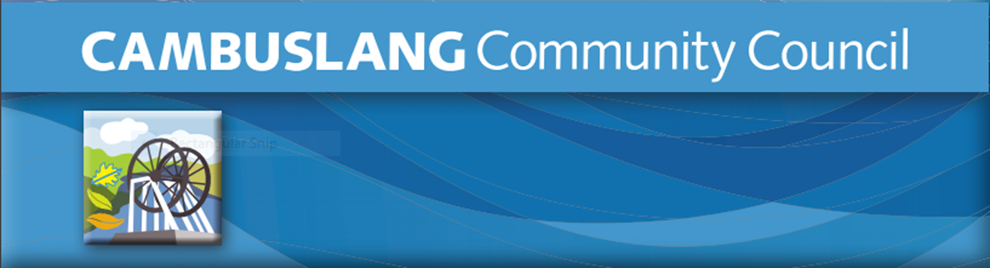
Renewable Energy Fund 2023/24

Cambuslang Community Activity Grant 2024

Application Form

Please read the guidelines BEFORE completing this form.

All sections MUST BE completed. The completed application form can be returned electronically to Cambuslang Community Council by email: cambuslangcomco@aol.com

About your organisation
Section 1: Contact details
Name of Individual, Group or
Organisation
Are you applying as an individual or a group?
Contact name
Group/Organisation website address
(if applicable)
Email address
Contact Telephone Number | Daytime: | Mobile:
Correspondence address
(including postcode)
Organisation
address
(if different from above)
Will the activity/project take place within Cambuslang West  Please check Cambuslang West boundary map via link below.  https://cambuslangcommunitycouncil.com/wp-content/uploads/2014/08/Council-area.pdf |  |  | Yes/No

Section 2: About your organisation (Individuals do not need to complete this section)
When was your group/organisation established?
Do you have a signed
constitution? (Yes/No)
Total Income  last accounting year?  (New groups: projected income in first year) | Total Surplus/Deficit  last accounting year? | Current  unrestricted reserves
£ | £ | £
Bank account details

Please note that awards can only be made to groups/organisations that have a bank account.
Name of Bank

Account number

Account name

Sort code
What are the main activities of your organisation/what service do you provide?

Section 3: Grant application details

Please describe the project / activity you are looking to fund

Please confirm how you will use any grant awarded in relation to this project
Please describe how this project will:

a)Enhance the quality of life for local residents;

b)Contribute to a vibrant, healthy successful & sustainable community; and/or

c) Promote community spirit and encourage community activity.
How many people will this Community Activity Grant
benefit?
How much are you applying to the fund for?  (Please note that there is no  guarantee that you will receive the  requested amount due to the total fund and the volume of  applications.) | How much does your project cost? | When will the project take place?
£ | £
Will you be contributing any of your own funds to the project or undertaking local fundraising, or applying for other grants to help meet the costs?
If so, please state how much and how these funds have been raised.
Declaration
By submitting this application form to Cambuslang Community Council, you certify that the information contained in this application is correct, and that if you are awarded a grant, you will use it only for the purposes described above. You understand that decisions made by Cambuslang Community Council are final.

Signed: Date:

All sections MUST BE completed. The completed application form can be returned electronically to Cambuslang Community Council by email: cambuslangcomco@aol.com

Closing date for applications is Thursday 29 February 2024 at 5pm

